**Sponsorship Opportunities**

***Partnering with Pacific Symphony and Arts & Learning Conservatory   
offers unparalleled opportunities for brand alignment, unique client engagement and meaningful community impact***

Experience the electrifying fusion of classical, jazz, blues, and opera with *Symphonic Soul*, a powerful tribute to African American artists whose contributions have shaped the very heart of American music.

Conducted in part by Carl St.Clair, and curated by Debora Wondercheck, this

unforgettable concert honors the legacy of African American musicians, singers, and composers, guiding audiences through a journey from rich classical harmonies to the joyful, uplifting sounds of gospel.

With masterful performances that resonate across generations, *Symphonic Soul* promises an evening of inspiration, celebration, and unity for all who attend.

FEATURING MUSIC BY...

Coleridge-Taylor Perkinson

Margaret Bonds

Duke Ellington

Rev. Milton Biggham

Abel Meeropol

Sam Cooke

Reginald Heber

Kanye West

Civilla Durfee Martin

Charles H. Gabriel

Eugene Rogers

Mark Foster

This concert offers the following sponsorship opportunities:

* **Celebration of African American Culture:** Be a presenting sponsor for this impactful concert.
* **Exclusive Access:** Includes reception with the artists, Symphony, and ALC leadership.
* **Prominent Recognition:** Logo featured in event promotions and materials.

**Presenting Concert Sponsorship: $50,000**

**Benefits**

* Special Recognition as Symphonic Soul Concert Underwriter
* Up to Sixteen (16) VIP Tickets to the Concert
* Post-Concert Reception in Box Circle Club
* Listing in all printed concert programs (140,000 impressions)
* Meet-and-Greet with Guest Artists (to be confirmed)
* Photo Opportunities with Logo Background
* Sponsorship Recognized from the Stage
* Exclusive Box Circle Intermission Reception
* Recognition in Program Books and Title Program Page
* Dedicated post to Arts & Learning Conservatory Social Media Channels
* Invitation to Symphony’s Annual Gala and Concert Dress Rehearsal
* Featured Highlight on Symphony’s Webpage and Emails
* Sponsorship acknowledged in press release and in all publications and social

media channels (745,000 impressions)

* Logo on Symphony’s Website (232,000 impressions)
* Public acknowledgement of sponsorship in publications,

advertisements and program books

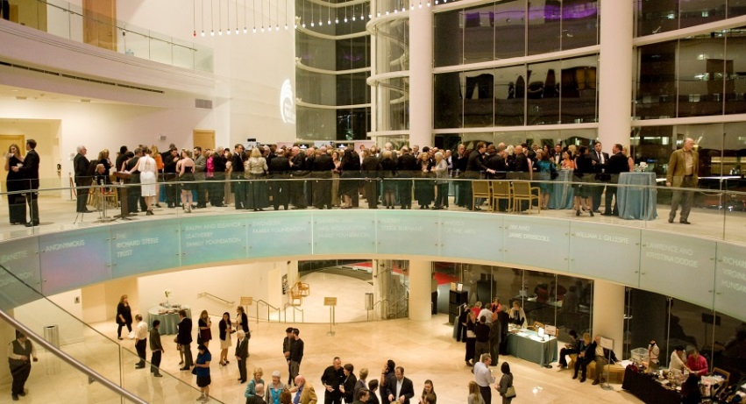

**Box Circle of the Renée and Henry Segerstrom Concert Hall**

**Box Circle Club Sponsorship: $20,000**

**Exclusive Reception:** Sponsor the pre-show and intermission reception for the Box Circle and VIP patrons.

**Benefits**

* Special Recognition as Box Circle Club Sponsor
* Up to Eight (8) VIP Tickets to the Concert
* Post-Concert Reception and Special Recognition
* Meet-and-Greet with Guest Artists (to be confirmed)
* Photo Opportunities with Logo Background
* Sponsorship Recognized from the Stage
* Exclusive Box Circle Intermission Reception
* Recognition in Program Books and Title Program Page
* Dedicated post to Arts & Learning Conservatory Social Media Channels
* Invitation to Symphony’s Annual Gala and Concert Dress Rehearsal
* Featured Highlight on Symphony’s Webpage and Emails
* Sponsorship acknowledged in press release
* Post-event photos in key local publications and magazines

**Artist Sponsorship: $20,000**

**Conductor/Artist Sponsorship:** Sponsor a prominent conductor or performer(s).

**Benefits**

* Special Recognition as Artist Sponsor
* Up to Eight (8) VIP Tickets to the Concert
* Post-Concert Reception in Box Circle Club
* Listing in all printed concert programs (140,000 impressions)
* Meet-and-Greet with Guest Artists (to be confirmed)
* Photo Opportunities with Logo Background
* Exclusive Box Circle Intermission Reception
* Dedicated post to Arts & Learning Conservatory Social Media Channels
* Invitation to Symphony’s Annual Gala and Concert Dress Rehearsal
* Featured Highlight on Symphony’s Webpage and Emails
* Sponsorship acknowledged in press release and in all publications and social

media channels (745,000 impressions)

* Logo on Symphony’s Website (232,000 impressions)
* Public acknowledgement of sponsorship in publications,

advertisements and program book

**Patron Sponsorship: $5,000**

**Benefits**

* Recognition as Patron Sponsor
* Two (2) VIP Concert tickets

**Sponsorship Benefits**

By supporting Pacific Symphony, you make a powerful impact in the community by deepening your position as a leading citizen in the corporate community, promoting core values and demonstrating an outstanding commitment to the arts in Orange County. The Symphony reaches a unique demographic of patrons that are closely aligned with the target market for prominent and recognized local entities, such as yours. Your gift is considered a charitable donation, as Pacific Symphony is a community, non-profit 501(c) 3 organization, supporting the arts and music education in Orange County.

**Customized Engagement & Benefits**

* **Tailored Visibility:** Each sponsorship opportunity comes with bespoke branding solutions to align with your goals
* **Client Activation:** VIP experiences, exclusive dinners and receptions designed to enhance client relationships.
* **Brand Recognition:** Across Pacific Symphony’s digital platforms, print materials, and on-site events.

**Contact Information**

**Emily Rankin**

**Vice President of Development  
Pacific Symphony**

**714.876.2398**[**ERankin@PacificSymphony.org**](mailto:ERankin@PacificSymphony.org)

**Debora Wondercheck, M.S., ED  
Chief Executive Officer   
Arts & Learning Conservatory  
714.638.8194**[**Debora@artsandlearning.org**](mailto:Debora@artsandlearning.org)